Exercises Biol-480 “Neuroscience I” - Neuroanatomy and Techniques (12/09/2025)

General Questions

- Cite 4 imaging techniques non-invasive and in vivo.
- What are the three main protections of the brain?
- Cite 2 techniques by which protein expression can be measured in the brain.

Case 1

A 51-year-old man came to an ophthalmology appointment complaining of 8 months of progressive visual loss and headaches. He was found to have bilateral mild papilledema, with some pallor of the right optic disc, visual fields with enlarged blind spots, and concentric loss of the peripheral visual fields in both eyes (he could see only the center of the visual field with either eye). The remainder of his neurologic exam was normal.

- Which fluid surrounds the brain and spinal cord, and where is it normally produced? What are the main functions of this fluid?
- Headaches with papilledema are signs of elevated intracranial pressure. Based on the patient’s symptoms (headaches, papilledema, visual field changes), what is the most likely cause of the elevated intracranial pressure in this case?
- Which imaging technique would you like to use in this case?
- A head examination was perforned with MRI (Figure 1). What type of section of the brain are you looking at? Coronal, sagittal or horizontal?
- What do you observe? Does it confirm your hypothesis?
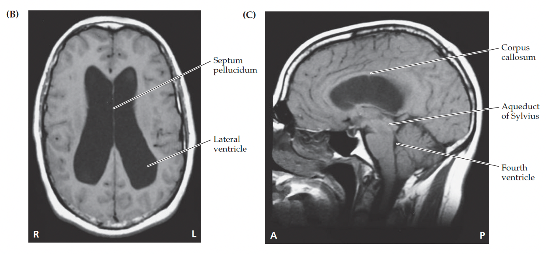
Figure 1. MRI scan Images. Headaches and progressive visual loss in 51-year-old man.

Experiment

Kim et al. (2016) has identified the ventromedial prefrontal cortex, specifically the infralimbic cortex (IL), as a critical brain structure in the learning of conditioned fear. How would design your experiment to come to this conclusion?

- Cite 2 techniques to study the function of brain cells in animal models.
- What animal model would you choose in this case, and why?
- Which technique would you use to study the function of the infralimbic cortex specifically?
- How would you anatomically verify that the expression is confined to IL?
- How would you assess the learning of conditioned fear and what will you quantify?

